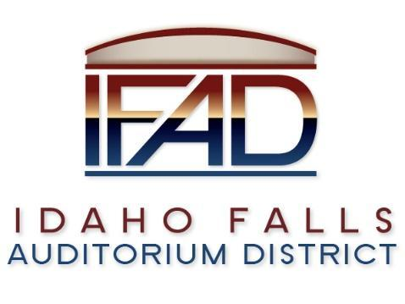
Board of Directors Special Meeting
Friday, April 30, 2021, 7:00 a.m.
Location: Idaho Falls Auditorium District Office/Zoom Videoconference
https://zoom.us/j/8694715148
467 Constitution Way, Idaho Falls, Idaho 83405
Agenda

- Call to Order

- Discussion Item - Public Comment

- Action Item – Naming Rights Approval

- Action Item – Naming Rights Approval

- Calendar and Announcements
  - Upcoming IFAD Meeting/Events – Next Meeting on May 11, 2021 Discussion Item - Announcements and Minor Questions
  - Discussion Item - Agenda Items for May 11, 2021 meeting

- Action Item - Adjournment from Public Session

Posted on or before 7:00 a.m. on April 29, 2021

