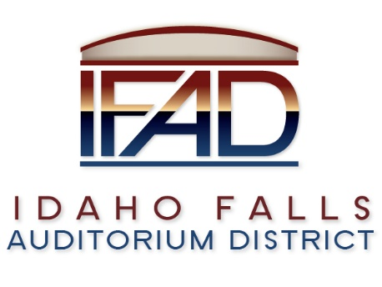
2022 IFAD General Business Meetings of the Board of Directors
Board Meetings are held on the Second and Fourth Tuesdays of each month at 7:00 a.m., in the IFAD office at 467 Constitution Way Idaho Falls, ID 83402. (*Unless otherwise noted)
Following is a list of Board of Directors’ Meeting dates for the 2022 Calendar Year:
January 11 and January 25
February 8 and February 22
March 8 and March 22
April 12 and April 26
May 10 and May 24
June 14 and June 28
July 12 and July 26
August 9 and August 23
September 13 and September 27
October 11 and October 25
November 8 and November 22
December 13

NOTICE POSTED PURSUANT TO IDAHO OPEN MEETING LAW CODE 67-2343

