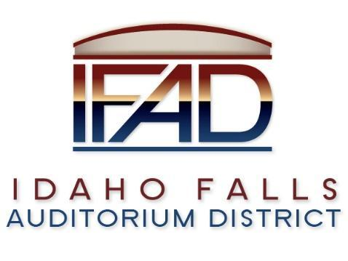
Board of Directors Special Meeting
Friday, November 2, 2021, 7:00 a.m.
Location: Idaho Falls Auditorium District Office/Zoom Videoconference
https://us06web.zoom.us/j/85004230687
467 Constitution Way, Idaho Falls, Idaho 83405
Agenda

- Call to Order

- Discussion Item - Public Comment

- Action Item – FF&E Financing Plan Approval

- Calendar and Announcements
  - Upcoming IFAD Meeting/Events – Next Meeting on November 9, 2021
  - Discussion Item - Announcements and Minor Questions
  - Discussion Item - Agenda Items for November 9, 2021, meeting

- Action Item - Adjournment from Public Session

Posted on or before 7:00 a.m. on November 1, 2021

