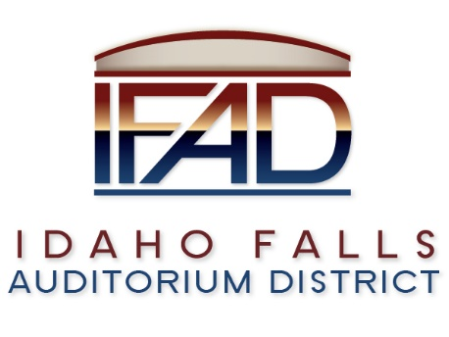
2021 IFAD General Business Meetings of the Board of Directors
Board Meetings are held on the Second and Fourth Tuesdays of each month at 7:00 a.m., in the IFAD office at 467 Constitution Way Idaho Falls, ID 83402. (*Unless otherwise noted)
Following is a list of Board of Directors’ Meeting dates for the 2021 Calendar Year:
January 12 and January 26
February 9 and February 23
March 9 and March 23
April 13 and April 27
May 11 and May 25
June 8 and June 22
July 13 and July 27
August 10 and August 24
September 14 and September 28
October 12 and October 26
November 9 and November 23
December 14

NOTICE POSTED PURSUANT TO IDAHO OPEN MEETING LAW CODE 67-2343

