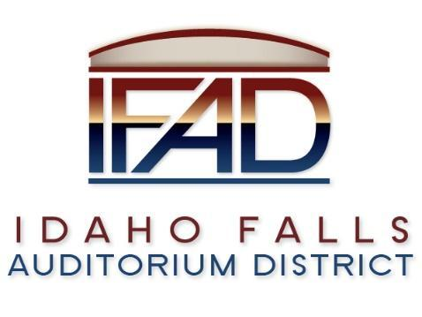
Board of Directors Business Meeting
Tuesday 9, April 2019, 7:00 a.m.
Location: Idaho Falls Auditorium District Office
467 Constitution Way, Idaho Falls, Idaho 83405
Agenda

- Call to Order
- Action Item - Accept the Consent Agenda
  - Meeting Minutes – 3/25/19, 3/26/19, 4/1/19
  - Financials and payables

- Discussion Item - Public Comment

- Action Item – Conference call system
- Action Item – Centennial Management Contract

- Discussion Item – Action Item Checklist
- Discussion Item – Update on the progress of the naming rights campaign

- Discussion Item – CRSA presentation regarding completion of design documents

- Report and Updates
- Discussion Item - Legal Report

- Calendar and Announcements
  - Upcoming IFAD Meeting/Events – Next Meeting on April 23, 2019
  - Discussion Item - Announcements and Minor Questions
  - Discussion Item - Agenda Items for April 23rd meeting

- Executive Session – Idaho Code Section 74-206(1)(a) To allow the Board to discuss the negotiations to hire the new Executive Director

- Action Item – Action taken on matters discussed in Executive Session

- Action Item - Adjournment from Public Session
Posted on or before 7:00 a.m. on April 7, 2019

