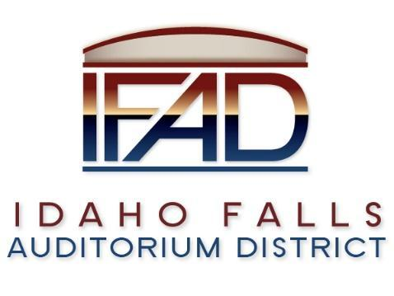
Board of Directors Business Meeting
Tuesday 23, April 2019, 7:00 a.m.
Location: Idaho Falls Auditorium District Office
467 Constitution Way, Idaho Falls, Idaho 83405
Agenda

- Call to Order
- Action Item – Accept agenda for this meeting
- Action Item - Accept the Consent Agenda
  - Meeting Minutes – 3/26/19, 4/9/19
  - Approve Payables

- Discussion Item - Public Comment
- Action Item – Approve addendum #3 to extend the Centennial Management MOU until May 19, 2020
- Action Item – Off Site Update – Tana Barney
- Action Item – Centennial Management Contract
- Discussion Item – Marketing/PR efforts – Chad Hammond
- Discussion Item – Update on the progress of the naming rights campaign
- Action Item – Update from Building Committee and Kevin DeKold: to provide suggestions on how decision making process should be handled with CRSA.
- Discussion Item – Owner’s representative – Bob Nitschke
- Report and Updates
- Discussion Item - Legal Report

- Calendar and Announcements
  - Upcoming IFAD Meeting/Events – Next Meeting on May 14, 2019
  - Discussion Item - Announcements and Minor Questions
  - Discussion Item - Agenda Items for May 14th meeting

- Executive Session – Idaho Code Section 74-206(1)(a) To hire the new Executive Director
- Action Item – Vote on the decisions made in Executive Session
- Action Item - Adjournment from Public Session
Posted on or before 7:00 a.m. on April 21, 2019
Zoom Meeting info:
Time: Apr 23, 2019 7:00
Join Zoom Meeting https://zoom.us/j/109093368
Meeting ID: 109 093 368

