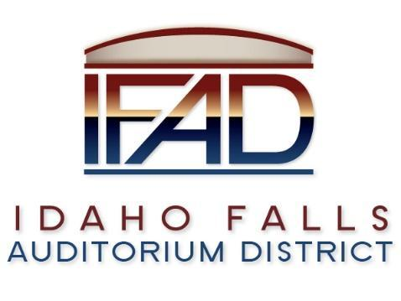
Board of Directors Special Meeting
Tuesday, 19 March 2019, 7:00 a.m.
Location: Idaho Falls Auditorium District Office
467 Constitution Way Idaho Falls, Idaho 83405

Attendees: Terri Gazdik, Bob Nitschke, John LoBuono, Doug Swanson, Steve Vucovich, Mark Fuller

Minutes

- Call to Order – at 7:05 a.m.

- Approve agenda – Motion to approve agenda. Seconded. Motion passes.

- Executive Session - Idaho Code Section 74-206 (1) (a) To consider hiring a staff member wherein the respective qualities of individuals are evaluated in order to fill a vacancy.

  - Entered executive session at 7:08 a.m.
  - Adjourned from executive session at 7:55 a.m.

- Action Item – action taken on matters discussed in Executive Session – No action taken.

- Adjournment from Public Session – Motion to adjourn at 8:00 a.m. Seconded. Motion passes.

