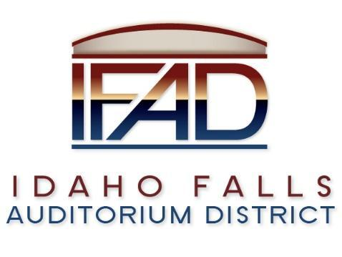
Board of Directors Special Meeting
Friday 1, March 2019, 7:00 a.m.
Location: Idaho Falls Auditorium District Office
467 Constitution Way Idaho Falls, Idaho 83405

Attendees: Terri Gazdik, Bob Nitschke, Doug Swanson, Steve Vucovich, Mark Fuller, Salem Thomas

- Call to Order – At 7:02 a.m.

- Approve agenda – Motion to approve the agenda. Seconded. Motion passes.

- Executive Session - Idaho Code Section 74-206 (1) (a) To consider hiring a staff member wherein the respective qualities of individuals are evaluated in order to fill a vacancy. Roll call vote – all in favor.
- Action Item – action taken on matters discussed in Executive Session – none.

- Adjournment from Public Session – 7:45 a.m.

