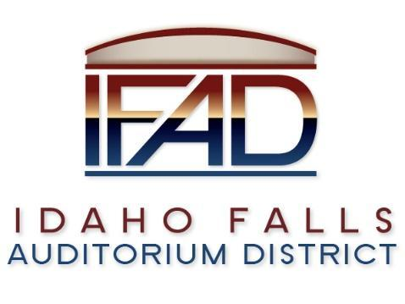
Board of Directors Business Meeting
Tuesday 26, February 2019, 7:00 a.m.
Location: Idaho Falls Auditorium District Office
467 Constitution Way Idaho Falls, Idaho 83402
Agenda

- Call to Order

- Action Item - Accept the Consent Agenda
  - Meeting Minutes – 2/12/2019
  - Approve IFAD Payables

- Discussion Item - Public Comment

- Discussion Item – Update on Centennial Management contract

- Action Item – CRSA Contract Review and Approval

- Action Item – Discuss and vote on Board Position Opening

- Discussion Item – Report of TEG Global search for Executive Director

- Report and Updates
- Discussion Item - Legal Report

- Calendar and Announcements
  - Upcoming IFAD Meeting/Events – Next Meeting on March 12, 2019
  - Discussion Item - Announcements and Minor Questions
  - Action Item - Agenda Items for March 12th meeting.

- Executive Session - Idaho Code Section 74-206 (1) (a) To consider hiring a staff member wherein the respective qualities of individuals are evaluated in order to fill a vacancy.

- Adjournment from Public Session
Posted on or before 7:00 a.m. on February 24, 2019

