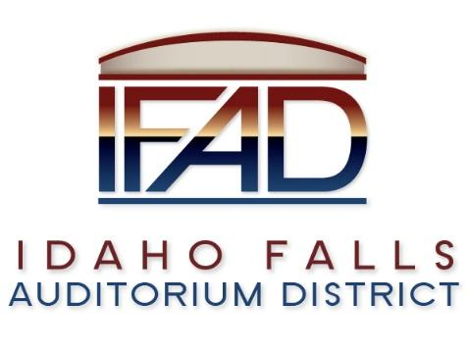

Board of Directors — Regular Business Meeting
425 N. Capital Ave., Idaho Falls, ID 83402
Tuesday, 22, May 2018, 7:00 a.m.

Location: The large conference room in Offices of Fuller & Beck
410 Memorial Drive
Suite 201, Idaho Falls, Idaho 83402

In Attendance: Board members Chair Terri Gazdik, Jill Kirkham, John LoBuono, Bob Nitschke, Executive Director Chip Scott,
Legal Counsel Mark Fuller, Blake Davis, Chad Hammond (IE Productions), Kevin Dekold (CRSA), Salem Rose Thomas, Steve Vucovich (Apple Athletic Club).

- Call to Order – Meeting is called to order at 7 a.m.

- Minutes May 22, 2018

- I.E. Productions Contract – Mark Fuller
Only change includes having I.E. Productions in every meeting unless excused by Executive Director. Document has already been signed by Chad Hammond. Asked for proposed changes for I.E.P’s document. Both parties recognize that the board is bound by the Idaho Public Records Act and the Idaho Open Meetings Law. Clarification on payment. I.E. Productions will be paid their normal retainer amount even when there are no upcoming events to be covered.
Motion and second to approve the Retainer Agreement proposal from I.E. Productions. Motion passed. Gazdik signed the document.

- Discussion on phone call with CSL – Chip Scott and Bob Nitschke
Nitschke still felt uninformed after the phone call so he proposed a work session to go through CSL analyses. Scott proposed a work session for June 6, at 12:30 with CSL to go over the things they have been studying. Scott will contact to confirm.
Mark Fuller talked about meeting with Joel Feldman talking about setting up of the board, and in regard with the board’s abilities to do something different than the current plan. Fuller mentioned that the city had decided to have an auditorium district, so there were specific things that would have to be done. Went through the process of developing the board. Nitschke asked what the voters had actually voted for and it was explained.
Scott has had conversations with Pathway. CSL is definitely underway with their studies.
Comment from construction manager: feasibility studies are to help you have an outside perspective. It is valuable to take what they say without forcing them to study something different that might skew the results.
Comment from citizen: be careful not to muddy the waters of the study.

- 4th of July Celebration – Chip Scott
IFAD will have a presence in the 4th of July celebration at Snake River Landing. We will need someone there from 10 am to 10 pm. Gazdik offered her easy-up for shade. Discussion of things we can give away. Research required, and recommendations for regalia from Scott next meeting.

- Storage of Ice Floor – Chip Scott
We were contacted by Doug Powell about the storage of the ice floor at Western Wholesale. It has been stored for free in the past, but now they want rent for the 900 sq ft space for $250 per month, with a $500 deposit, over a 2 year period. Alternate option is to find somewhere else to store the floor for cheaper. Centennial Management bought the floor and the Zamboni, therefore we need to send the necessity of storage space to CM to discuss the rent space. One option is to contact the scout office to see if we can use their space. LoBuono suggested we may need to make a joint agreement with CM because they bought it for us. After Scott contacts CM he will get back to Fuller. Bring this back up in the next meeting.

- Weekly Executive Directors Report – Chip Scott
Q: What triggered the meeting with the Mayor? - Nitschke
A: I wanted to understand what their plans are for upgrading facilities as we decide where we are headed.
LoBuono brought up his discussions he has had about not building the event center in order to have the money for the building a rec center instead. The money could not go back to the city. This idea has been calmed but not forgotten.

Draft of document control plan. The focus is on electronic storage of documents so everyone has continual access to them. It assigns responsibility to admin coordinator to start sorting through paper files. Everyone look through this and see what is missing. Everyone has the Risk Management Plan. It will give you direction on our plan for risk management. Timeline - We need to get this document solidified. There is a copy in SmartSheet online. There is a Gant version and a list document. Scott will make sure everyone has access to all of this information.
CSL will have their report to us at the end of June. CSL draft board report was originally May 28, but needs to be updated. We will push Pathway Associates off until we get the CSL report. We have a letter acknowledging that.

- Legal Report - Mark Fuller
Document on Pathway extension to put a hold on contract. Made with Phyllis. They will recommence services when the executive director asks them to begin again.

- Calendar – Terri Gazdik
Change next meeting from June 5, 2018 to June 12, 2018. Work meeting June 6, 2018 with CSL.

- Design Requirements – Bob Nitschke
Bob Nitschke wants design requirements. Kirkham talks about Kevin having a design requirement page. Scott already has it. It is two pages long. Bob doesn’t think it covers the requirements. Gazdik explains the difference between memorializing what the past boards have done, and creating a new document based on what we think we need now. LoBuono explained that we need the study to tell us if the design we have created will cover what things we need. Public comment explains that it has been done correctly so far. The board doesn’t pay until they approve of the design. Nitschke thinks the public should know what the design requirements are. Discussion on how to satisfy Nitschke’s wants. Gazdik suggested that Bob go through the things that the construction manager has put together and then suggest the things that are missing.

- Input for June 12th agenda: none. Get them to Scott if arise later.

- Motion to adjourn. Seconded. Passed.

