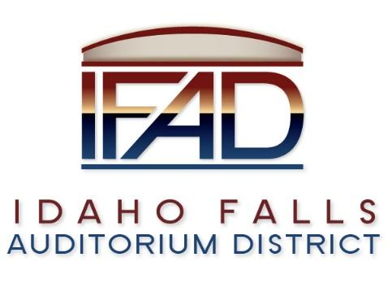

Board of Directors — Regular Business Meeting
425 N. Capital Ave., Idaho Falls, ID 83402
Tuesday, 12, June 2018, 7:00 a.m.

Location: The large conference room in Offices of Fuller & Beck
410 Memorial Drive Suite 201, Idaho Falls, Idaho 83402

In Attendance: Board members Chair Terri Gazdik, Jill Kirkham, John LoBuono, Doug Swanson, Bob Nitschke, Executive Director Chip Scott,
Legal Counsel Mark Fuller, Mike Clements (BH), Chad Hammond (IE), Eric Isom (BV), Rebecca Casper (CIF), James West (Inntrusted), Salem Thomas, Kevin Dakota (CRSA), Isabella Alves (Post Register).

- Call to Order – Meeting is called to order at 7 a.m.
- Motion to remove meeting minutes 5-8-2018.
Motion to accept consent agenda. Seconded. Passed.

- Review and approval of IFAD payables. April 30 financials were distributed. LoBuono asked where the board is with making sure bed and breakfasts are paying the tourist tax. There is an entity that is willing to take over to make sure they are paying. The name is uncertain, but Scott will have a conversation with the hotel group to see if they are helping.

- Public comment - (No public comment)

- 4th of July – Chip Scott
Scott put together an agenda for the board to attend and participate in handing out swag. Hammond is putting together a FAQ sheet to help with those questions with the public.

- Ground Breaking Event – Chip Scott
Scott contacted Ball Ventures about participating with ground breaking event in the month of August. Discussion on what kind of event we want to have. Hammond approves of the idea. The event will help get started with fundraising. We could work with Pathway on it. Scott will put together some scenarios and a budget to discuss next meeting. Board preference is to have a performance of some sort. Purpose would be to have media attend, but we want the public there as well so the media has something to cover. Eric from Ball Ventures offered the WaterFront for the location. Discussed dates for end of August.

- Public Relations for Board Members – Chip Scott
Scott discussed the idea of having each board member meet with Chad Hammond in order to help with things said on record. Board members agreed to participate in training in order to be able to “talk positive communications.”

- Event Center Design Requirements – Bob Nitschke
Definition of requirement written on board. Request to write a document that has all requirements for the event center. Example of vision for building: “Go to place for all residents of SE Idaho, tourists, and companies for entertainment, cultural, educational and business related events for the next fifty years.” It helps us identify the who, what, and when. Requirements identify the “how.” We should identify all the “whos” and then survey them to ask what would make them want to come and what makes them want to come back. Other major area is to not just say “basketball,” but declare we want to be able to host the “5A High School state basketball tournament.” Other examples mentioned include workroom, bridge players, dog shows, John Deere convention, safety and security, etc. Last worry is cost. We need to declare to the AE our budget. Nitschke will work with Chip and decide on requirement designs.

- Executive Directors Report – Chip Scott
New Admin is Salem Thomas. Will start on the June 18, 2018 as the part time job discussed.
Update on business advisory committee. We have told them to “sit tight.” They will be helping us with our prospect list. (Donors)
Asked for questions regarding weekly report.
Q: have you met with the Mayor and Parks and Rec Department?
A: I postponed it.

- Legal Report - Mark Fuller
All Hoteliers are current. Everyone has paid in full. One difficult one has started paying on time.
Meeting tomorrow with representatives from state tax collection to meet at 1:00 pm with Scott, Fuller and Gazdik to discuss these points among others:
1. Review and understand current situation
2. Describe current state processes
3. Begin building a list of your requirements
4. Discuss potential costs and billing

- Agenda items June 26, 2018 (next meeting) – Terri Gazdik
Request for update on CSL from Nitschke
Report on tomorrow’s meeting from Fuller
Fuller will not be in attendance.

- Motion to adjourn. Seconded. Passed.

