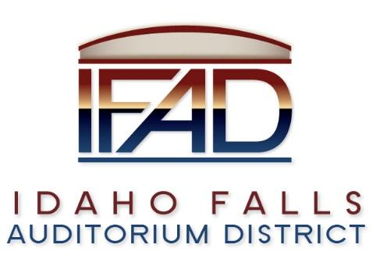

Board of Directors — Regular Business Meeting
425 N. Capital Ave., Idaho Falls, ID 83402
Tuesday, 24, April 2018, 7:00 a.m.

Location: The large conference room in Offices of Fuller & Beck
410 Memorial Drive
Suite 201, Idaho Falls, Idaho 83402

Agenda

- Call to Order

- Adoption of the Consent Agenda
  - Meeting Minutes – 3/27/18
  - Approval of IFAD Payables
  - Financials

- Public Comment – anyone wishing to provide public comment will be given 3 minutes

- Feasibility Study and Status Report from CSL

- Timing of Fundraising Campaign & Coordination with Feasibility Study

- Public Relations Committee PR RFP Recommendation

- Board Meeting Cancellation Policy

- Board Meeting Agendas

- Report and Updates
- Executive Director’s Report - Weekly Report Detail
- Legal

- Calendar and Announcements
  - Upcoming IFAD Meeting/Events – Next Meeting on May 9, 2018
  - Announcements and Minor Questions

- Adjournment
Posted on or before 7:00 a.m. on April 22,, 2018

