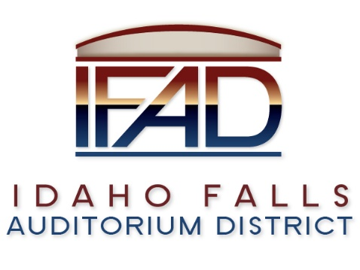
Board of Directors — Regular Business Meeting
425 N. Capital Ave., Idaho Falls, ID 83402
Tuesday, 13, March 2018, 7:00 a.m.

Location: The large conference room in Offices of Fuller & Beck
410 Memorial Drive
Suite 201, Idaho Falls, Idaho 83402
Agenda

- Call to Order

- Adoption of the Consent Agenda
  - Meeting Minutes – 2/27/18
  - Approval of IFAD Payables
  - Approval of January Financial Statement

- Public Comment – anyone wishing to provide public comment will be given 3 minutes

- Hockey Leagues 101 – Kevin Greene, Centennial Management
- Centennial Management Memorandum of Understanding Review

- Review & Approval of CSL Feasibility Study Contract
- Review of Board Policies III & IV – Public Records/Interaction with Media

- Pathway Associates Presentation – Phyllis Hockett, Dave Jones

- Report and Updates
- Executive Director’s Report
- Public Relations RFP Update
- Legal
- Calendar and Announcements
  - Upcoming IFAD Meeting/Events – Next Meeting on March 27, 2018
  - Announcements and Minor Questions

- Adjournment

Posted on or before 7:00 a.m. on February 9, 2018

