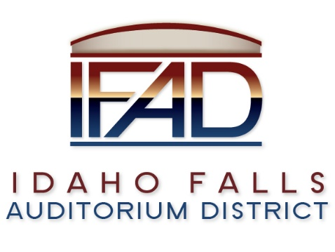

Board of Directors — Regular Business Meeting Minutes
425 N. Capital Ave., Idaho Falls, ID 83402
Tuesday, 27 February 2018, 7:00 a.m.

Location: The large conference room in the
Offices of Fuller & Beck
410 Memorial Drive
Suite 201
Idaho Falls, Idaho 83402

In attendance: Board Members Chair Terri Gazdik, John LoBuono, Doug Swanson, Robert Nitschke and Jill Kirkham; Executive Director Chip Scott, Administrative Coordinator Brandace Novack, Tana Barney, Kassy Shepherd, Mike Clements, Jim Adkins, Monica Ramsey, Blake Davis, Isabella Alves, Steve Vucovich and Eric Isom.

Agenda

- Call to Order – Chair Gazdik called meeting to order at 7:02 a.m. Board Member Kirkham made a motion to move item 7 on the agenda to item 5. Motion is seconded. All in favor. Motion passes. Mr. Nitschke would like to see the public information policy discussed by the Board at the next meeting. He would like to see the minor league hockey status reviewed, which is listed as a line item on the Minor Questions section of the agenda.

- Adoption of the Consent Agenda
  - Meeting Minutes – 1/9 – approved with revisions. 1/15, 1/23 – Mr. Sayer and Mr. Hernandez co-chairs proposed. Approved with revisions. 2/6 – Board Member Nitschke – start with 7 – questioning of the statement regarding the minor league team. It is noted that it could be ten to fifteen years to add a second team with full community support. 2/16 – Roads and Bridges correction noted. 2/6 - Mr. Nitschke would like to add the consideration of a minor hockey league to the feasibility report. Acronym for the East Coast Hockey League (ECHL) is corrected on the agenda. A motion is made to approve minutes as modified. Motion is seconded. All in favor. Motion passes.

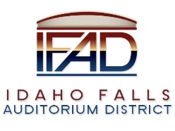

  - Approval of IFAD Payables – There is a motion to pay the payables. Motion is seconded. All in favor. Motion passes.

- Public Comment – There was no public comment.

- Audit Presentation – Rudd & Co. – Audit report extends to the end of the fiscal year, November 30, 2017. In the auditing process, there is a segregation of duties. Please keep this in mind when reading through the report. Through the auditing procedures, it is Rudd & Company’s determination that the materials are free of misstatement. The reports are considered correct. Receivable for taxes are similar to the previous year. Collections are slightly larger than last year. Pre-construction costs are primarily architectural fees, which is a summation of all architectural expenses for the entirety of the project to date. Not all engineering fees are totaled to date. Page 13 – The fund balance at the bottom is split between committed amounts and amounts not yet committed. Committed amounts are bridge and road design and property lease for the IFAD executive suite. 2.2 million dollars was collected last year. Interest income is up as assets increase and accumulate. On page 26, there is a detailed income statement comparing the amounts that are budgeted. Payroll expenses were expected to be more as there wasn’t an Executive Director for a portion of the year, therefore, there is an adjustment in this expenditures. There is a motion to accept the audit report. The motion is seconded. All in favor. Motion passes. Action: Legal Counsel, Mr. Fuller, will file the audit report with Legislative Services – State of Idaho.

- Review and Discussion of Road and Bridge Development Agreement – Provisions to the agreement have been discussed over time. There are three main issues after discussions with the contractor: a. cost allocation between IFAD and Pioneer Front Properties; b. easement for the sign c; Pioneer Road costs. The donation agreement will be completed once the road and bridge agreement is finalized. The city and the county are asking that the road be
improved. There is some modification to the agreement. Postponing the construction of the road could be a benefit. Pioneer Front Properties (PFP) has never wavered from the understanding that the Idaho Falls Event Center would bear one hundred percent of the cost for Pioneer Road Construction. Initially, PFP had a proposal different than the current proposal. As things progressed, the plans changed to shift the building to the north and have the road go all the way through. IFAD would pay for half of all the roads.

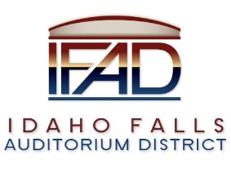

V., cont.

PFP donated the twenty-three acres for the Events Center. Mr. Fuller noted that the IFAD frontage is only twenty-five percent of total. It was determined that IFAD would pay approximately thirty-eight percent. The donation agreement allows IFAD to recoup some of the costs. Any recouping of funds does not include road costs. Event Center Drive will belong to the city. Two clauses were addressed: a. if there is no construction after seven years, and, b. if there is no development then PFP has first position purchase rights to the property with a first right of refusal in place should IFAD decide to sell. IFAD agreed to first offer the property to Ball Ventures as agreed to in a contract to purchase real property with a first right of refusal clause. There is no option to recoup the road costs except through sale of the property. Another issue is the easement for the signage. PFP would like a sign for Snake River Development and the Events Center. Exact location is to be determined. Federal guidelines for the signage must be considered. A reader board may be on top of the post. This could add one hundred to one
hundred and twenty-five thousand dollars to signage costs. However, there is a revenue opportunity with the sign. Paragraph 2.4 on page 4 is referenced. Government guidelines could be modified at some point in the future. Board Member Swanson notes that many companies will be excited to advertise events on the sign. There is a mutual benefit for the sign, therefore, sharing the cost makes sense. There is no cost sharing for Pioneer Road. The property is presently owned by Pioneer Front Properties. Upon completion of the agreements at hand, the property ownership will be transferred to IFAD.
Board Member Kirkham asks what IFAD hopes to commit. Legal Counsel stated that Pioneer Road is not part of the agreement. The Events Center bridges have already been discussed. Totals for contingencies, utility charges, etc. are approximate – the remainder is what is split. Chair Gazdik suggests that the next step is to send out a bid package to get actual costs locked down. Construction costs are going up, said Mr. Isom. Construction costs are going up faster than interest gained on funds currently in the bank. Board member Kirkham points out that GBAD had a thirty year timeline for completion. IFAD has only seven years to complete construction unless the agreement is extended. What if more time is needed? Board Member Kirkham has concerns about approving the roads before the completion of the Feasibility study. Mr. LoBuono asked what the time allocation was for the road project. As road construction begins, IFAD will place $350,000 into an account. As work progresses and funds are used for the construction, the $350,000 balance will be replenished by IFAD. The road project is expected to take a year and a half.
Mr. LoBuono points out that with improvements, the value of the property

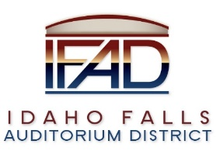

V., cont.

will increase in value in the unfortunate event IFAD has to sell the ground. Land with improvements is of greater value than just ground. Tana Barney pointed out that there is a prep period before construction can begin. She suggests a decision be made no later than late spring to allow for a pre-construction phase. Mr. LoBuono referenced the Pocatello Events Center as an example. Chair Gazdik said PFP has always supported the project as land developers. She strongly impressed that it is important to make a decision today. Mr. LoBuono and Mr. Swanson agreed. Board Member Kirkham’s biggest concern is moving forward without the Feasibility Study being completed. Mr. Swanson understands that the roads project is the next step to getting the Events Center completed. Board Member Nitschke would like to see a Project Management Plan in place. Mr. LoBuono would like to see both a Project Management Plan and a Business Plan in place. Board Member Swanson stated his strong belief that IFAD needs to make a commitment, especially in light of the public’s perception of the project’s inactivity without having an Executive Director on board over the last few months. There is a motion made to approve the Roads and Bridges agreement. The motion is seconded. There is a roll call vote: Chair Gazdik – yay. Jill Kirkham –nay. Doug Swanson - yay. Robert Nitschke – nay. John LoBuono – yay. There is a three to two vote in favor of the motion. Motion passes. Action: Legal Counsel authorized to complete contract execution.

- Final review of Public Relations Firm RFP – There is a motion to send out the Public Relations RFP. There is a second. All in favor. The motion passes.
Action: Executive Director Scott will send out RFPs to selected firms. Chair Gazdik thanked Mr. LoBuono for his hard work on the Public Relations RFP.

- Review and Discussion of Submitted Feasibility Study RFP’s – selection of a firm to complete the study is discussed. References reviewed go back to the early 2000’s, said Board Member LoBuono. Mr. LoBuono felt references from the last three years were more relevant. Board Member Nitschke has a few observations from the interviews with the three firms interviewed that responded to the RFP. Mr. Nitschke asked for upper and lower bounds. He wanted to see more examples given. He was discouraged that the examples didn’t span a thirty year timeline. CSL recognized there could be possible changes in the future. The event attendees’ interests could change and evolve over time. Mr. Nitschke proposed there be a fund included in the
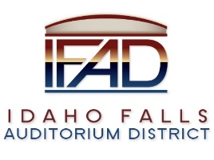

VII., cont.

capital improvements that could allow for changes over time. Mr. LoBuono evaluated size of projects, and analyzed the relevance of size when evaluating references. Executive Director, Chip Scott, agrees that all three companies are very capable. However, CSL stood out more than the other two firms in his view. Public comment by Kevin Greene – operating revenue for a team goes to operating expenses, not construction costs. Bozeman had a failed project where both operating and construction costs were included. There is a motion to begin the contract negotiating process with CSL. Motion is seconded. All in favor. Motion passes.

- Reports and Updates
- Administrative
  - Posting location for Notices and Agendas – waiting for bids on signs.
  - Thank you note to IdeACom for installation of the Cat 5 connection.
  - Executive Director’s Report – Mr. Scott – Regarding a credit card payments option. It is possible to set up credit card services as a courtesy to the hotels, and have the cost of using the service charged to the hotel.
- Legal
  - Legislative update – Auditorium District bill has been withdrawn. Urban Renewal Agency Funds – if 51% of funds for project come from urban renewal district then there must be 60% approval by the public in a vote.
  - Other – State Tax Commission email exchanges.

- Calendar and Announcements
  - Upcoming IFAD Meeting/Events – Next Meeting on March 13, 2018
  - Announcements and Minor Questions – What is the status of ECHL representative? Board Member Nitschke observed that there seemed to be a disconnect between having a junior and/or minor league team, and the Events Center plan as it currently stands. Mr. Greene agreed to help with the Management Plan for the two teams, and present findings to the Board at the March 13th meeting. Chair Gazdik thanked Mr. Greene for his help on behalf of the Board.
- Adjournment – There is a motion to adjourn meeting. Motion is seconded. All in favor. Motion passes. Meeting adjourned at 8:55 a.m.

