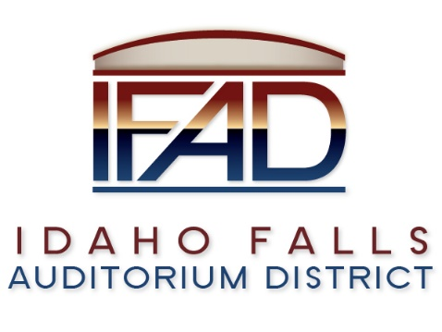
Board of Directors — Regular Business Meeting
425 N. Capital Ave., Idaho Falls, ID 83402
Tuesday, 27 February 2018, 7:00 a.m.

Location: The large conference room in the
Offices of Fuller & Beck
410 Memorial Drive
Suite 201, Idaho Falls, Idaho 83402

Agenda

- Call to Order – Chair Gazdik called meeting to order at 7:02 a.m. Board Member Kirkham moves to move item 7 on the agenda to item 4. Motion is seconded. All in favor. Motion passes. Mr. Nitschke would like to see the public policy discussed by the Board. He would like to see the minor league hockey status reviewed.

- Adoption of the Consent Agenda
  - Meeting Minutes – 1/9 – approved with corrections. 1/15, 1/23 – Mr. Sayer and Mr. Hernandez, 2/6 – Board Member Nitschke – start with 7 – questioning of the statement regarding the minor league, could be ten to fifteen years to add a second team(review recording) that the community support, 2/16 - 2018
  - Approval of IFAD Payables

- Public Comment – anyone wishing to provide public comment will be given 3 minutes

- Audit Presentation – Rudd & Co.
- Review and Discussion of Submitted Feasibility Study RFP’s – selection of firm
- Final review of Public Relations Firm RFP

- Review and Discussion of Road and Bridge Development Agreement

- Reports and Updates
- Administrative
  - Posting location for Notices and Agendas
  - Thank you note to IdeaCom for installation of the Cat 5 connection.
- Executive Director’s Report
- Legal
  - Legislative update
  - Other

- Calendar and Announcements
  - Upcoming IFAD Meeting/Events – Next Meeting on March 13, 2018
  - Announcements and Minor Questions – What is the status of ECHL representative?
- Adjournment

Posted on or before 7:00 a.m. on 25 February 2018

Page 2

