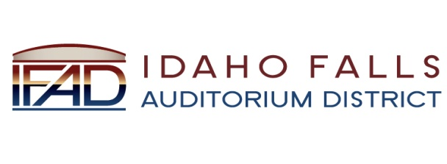
Board of Directors — Business Meeting
420 Memorial Drive, Idaho Falls, ID 83402
10 October 2012
7:30 a.m.

Agenda

- Call to Order.

- Adoption of the Agenda.

- Approval of Minutes from Previous Meetings.

- Approval of IFAD Payables.

- Review of Proposed Audit Procedures—Fred Goodworth

- Reports and Updates.
  - Architectural Report.
  - Office Update.
  - IFAD Logo Update.
  - Other Reports.

- Discussion of Investment Options.

- Personnel Considerations.

- Consideration of Records Retention Draft Policy.

- Calendar and Announcements.
  - Upcoming IFAD Meetings.
  - Announcements and Minor Questions.

- Public Comment.

- Adjournment.

