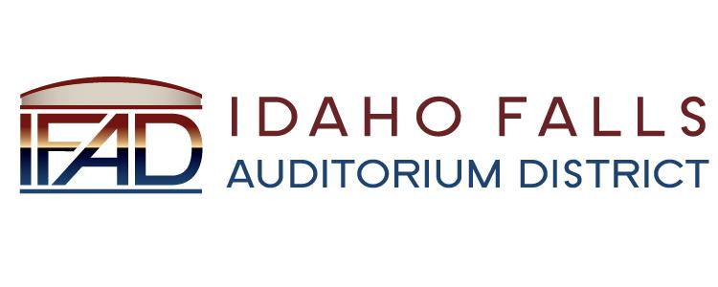
NOTICE POSTED PURSUANT TO IDAHO OPEN MEETING LAW CODE 74-204

Idaho Falls Auditorium District

A Business Meeting of the Board of Directors
will be held at the following location:

IFAD Office 467 Constitution Way
Idaho Falls, ID 83402

Tuesday, April 9, 2019

7 AM

Notice posted on or before April 4, 2019 at 7 AM
Date and time subject to change

Topic: admin@idahofallsauditoriumdistrict.com's Zoom Meeting
Time: Apr 23, 2019 7:00 AM Mountain Time (US and Canada)

Join Zoom Meeting
https://zoom.us/j/109093368

Dial by your location
+1 408 638 0968 US (San Jose)
+1 646 558 8656 US (New York)
Meeting ID: 109 093 368
Find your local number: https://zoom.us/u/aXOywDVth

