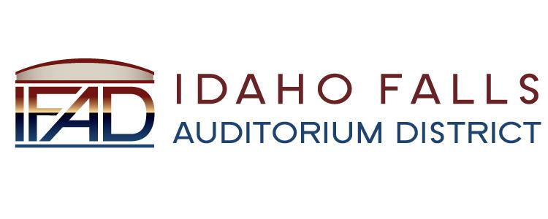
NOTICE POSTED PURSUANT TO IDAHO OPEN MEETING LAW CODE 74-204

Idaho Falls Auditorium District

A Business Meeting of the Board of Directors
will be held at the following location:

IFAD Office 467 Constitution Way
Idaho Falls, ID 83402

Tuesday, April 23, 2019

7 AM

Notice posted on or before April 18, 2019 at 7 AM
Date and time subject to change

