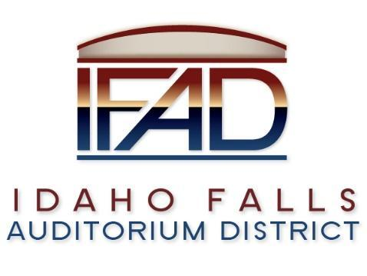
Board of Directors Special Meeting
Thursday 7, March 2019, 7:00 a.m.
Location: Idaho Falls Auditorium District Office
467 Constitution Way Idaho Falls, Idaho 83405

Attendees: Terri Gazdik, Bob Nitschke, John LoBuono, Steve Vucovich, Mark Fuller

Minutes

- Call to Order – At 7:15 a.m.

- Approve agenda - Motion to approve agenda. Seconded. Motion passes.

- Executive Session - Idaho Code Section 74-206 (1) (a) To consider hiring a staff member wherein the respective qualities of individuals are evaluated in order to fill a vacancy.
  - Convened at 7:19 a.m.
  - Adjournment at 9:34 a.m.

- Action Item – action taken on matters discussed in Executive Session – none.

- Adjournment from Public Session – Motion to adjourn. Seconded. Motion passes at 9:35 a.m.

