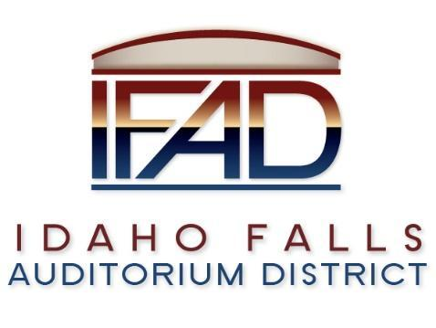
Board of Directors Business Meeting
Tuesday 26, March 2019, 7:00 a.m.
Location: Idaho Falls Auditorium District Office
467 Constitution Way, Idaho Falls, Idaho 83405
Agenda

- Call to Order

- Action Item - Accept the Consent Agenda
  - Meeting Minutes – 3/12/19, 3/19/19
  - Payables

- Discussion Item - Public Comment

- Action Item - Presentation of audit report by Rudd & Co

- Action Item – Approval of reimbursement amounts for CRSA

- Discussion Item –Draft of Centennial Management contract

- Action Item – status on Executive Director search.

- Discussion Item – update on the progress of the naming rights campaign

- Discussion Item – Schematic design narrative

- Report and Updates
- Discussion Item - Legal Report

- Calendar and Announcements
  - Upcoming IFAD Meeting/Events – Next Meeting on April 9, 2019
  - Discussion Item - Announcements and Minor Questions
  - Action Item - Agenda Items for April 9th meeting.

- Adjournment from Public Session
Posted on or before 7:00 a.m. on March 24, 2019

