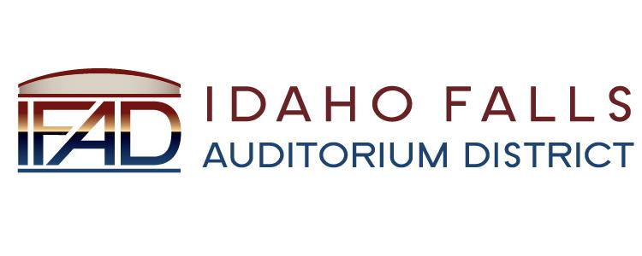
NOTICE POSTED PURSUANT TO IDAHO OPEN MEETING LAW CODE 74-204(2)

Idaho Falls Auditorium District

A Special Meeting of the Board of Directors
will be held at the following location:

IFAD Office 467 Constitution Way
Idaho Falls, ID 83405

Monday, March 25, 2019

6:30 PM

Notice posted on or before March 23, 2019 at 6:30 PM
Date and time subject to change

