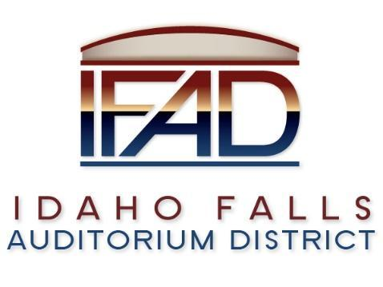
Board of Directors Special Meeting
Tuesday, 19 March 2019, 7:00 a.m.
Location: Idaho Falls Auditorium District Office
467 Constitution Way Idaho Falls, Idaho 83405
Agenda

- Call to Order

- Approve agenda

- Executive Session - Idaho Code Section 74-206 (1) (a) To consider hiring a staff member wherein the respective qualities of individuals are evaluated in order to fill a vacancy.
- Action Item – action taken on matters discussed in Executive Session

- Adjournment from Public Session

Posted on or before 7:00 a.m. on March 17, 2019

