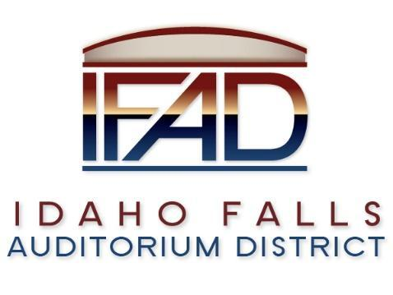
Board of Directors Business Meeting
Tuesday 12, March 2019, 7:00 a.m.
Location: Idaho Falls Auditorium District Office
467 Constitution Way, Idaho Falls, Idaho 83405
Agenda

- Call to Order
- Action Item – Swear in new board member
- Action Item - Accept the Consent Agenda
  - Meeting Minutes – 2/26/2019, 3/1/2019, 3/7/2019
  - Approve IFAD Payables and Financials

- Discussion Item - Public Comment
- Action Item – consider and adopt Guidelines for Public Records location designations, as well as records custodian and alternate custodian designations, as required by Idaho Code Section 74-119

- Discussion Item – Update on Centennial Management contract
- Discussion Item – CRSA update
- Discussion Item – status on Executive Director search. Scheduling of further interviews.

- Discussion Item – update on the progress of the naming rights campaign

- Report and Updates
- Discussion Item – Update on audit report
- Discussion Item - Legal Report

- Calendar and Announcements
  - Upcoming IFAD Meeting/Events – Next Meeting on March 26, 2019
  - Discussion Item - Announcements and Minor Questions
  - Action Item - Agenda Items for March 26th meeting.

- Adjournment from Public Session
Posted on or before 7:00 a.m. on March 10, 2019

