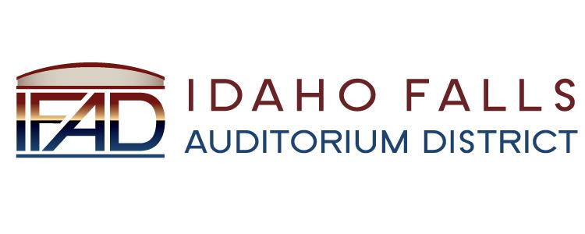
NOTICE POSTED PURSUANT TO IDAHO OPEN MEETING LAW CODE 67-2343

Idaho Falls Auditorium District

A Business Meeting of the Board of Directors
will be held at the following location:

IFAD Office 467 Constitution Way
Idaho Falls, ID 83405

Tuesday, February 26, 2019

7 AM

Notice posted on or before February 21, 2019 at 7 AM
Date and time subject to change

