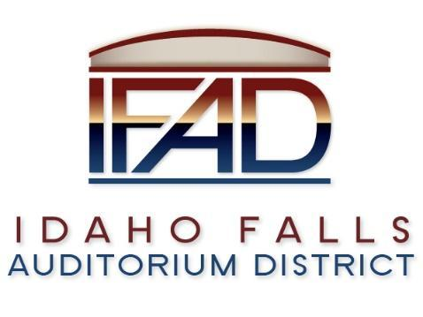
Board of Directors Business Meeting
Tuesday 12, February 2019, 7:00 a.m.
Location: Idaho Falls Auditorium District Office
467 Constitution Way Idaho Falls, Idaho 83402
Agenda

- Call to Order

- Action Item - Accept the Consent Agenda
  - Meeting Minutes – 1/22/2019
  - Approve IFAD Payables and Financials

- Discussion Item - Public Comment

- Action Item – Election of secretary/treasurer

- Discussion Item – Potential Board replacements for Jill Kirkham

- Discussion Item - Terms of centennial management contract in order to ensure tax exempt statute on financing

- Action Item – Decision on changing to Highway Commercial designation

- Discussion Item – Report of TEG Global search for Executive Director

- Report and Updates
- Action Item – Report on Interim Executive Director Search
- Discussion Item - Legal Report

- Calendar and Announcements
  - Upcoming IFAD Meeting/Events – Next Meeting on February 26, 2019
  - Discussion Item - Announcements and Minor Questions
  - Action Item - Agenda Items for February 12th meeting.

- Adjournment from Public Session
Posted on or before 7:00 a.m. on February 10, 2019

