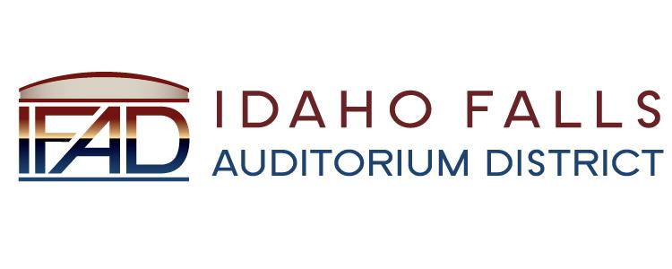
NOTICE POSTED PURSUANT TO IDAHO OPEN MEETING LAW CODE 74-204

Idaho Falls Auditorium District

A Special Meeting of the Board of Directors will be held at the following location:

IFAD Office 467 Constitution Way
Idaho Falls, ID 83402

Tuesday, January 15, 2019

4 PM

Notice posted on or before January 14, 2019 at 4 PM
Date and time subject to change

