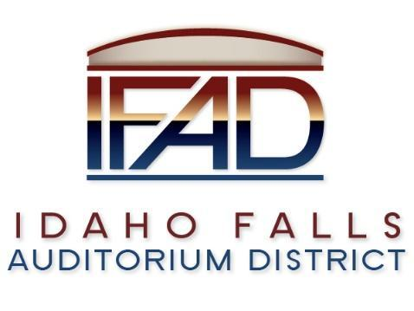
Board of Directors Business Meeting
Tuesday 22, January 2019, 7:00 a.m.
Location: Idaho Falls Auditorium District Office
467 Constitution Way Idaho Falls, Idaho 83402
Agenda

- Call to Order

- Action Item - Accept the Consent Agenda
  - Meeting Minutes – 12/11/2018, 1/8/2019 and 1/15/2019
  - Approve IFAD Payables

- Discussion Item - Public Comment

- Action Item – Zoning Change Request - Gazdik

- Discussion Item - Project Management Plan Review

- Discussion Item - Action Item Checklist Review

- Discussion Item – Report on TEG Global search for Executive Director

- Discussion Item – Update from Pathway on Naming Rights Campaign

- Discussion Item – Public Relations and Media Update – Chad Hammond

- Report and Updates
- Action Item – Report on Interim Executive Director Search
- Discussion Item - Legal Report
- Calendar and Announcements
  - Upcoming IFAD Meeting/Events – Next Meeting on February 12, 2019
  - Discussion Item - Announcements and Minor Questions
  - Discussion Item - Agenda Items for February 12th meeting.
- Discussion Item – Executive Session – Idaho Code 74-206 (1) (f) to communicate with legal counsel on controversy not yet being litigated but imminently likely to be filed.
- Action Item – action taken on matters discussed in Executive Session

- Adjournment from Public Session
Posted on or before 7:00 a.m. on January 20, 2019

