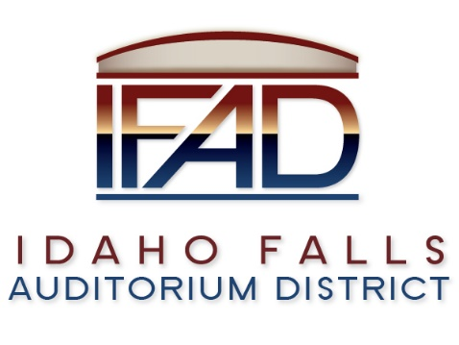
Board of Directors — Regular Business Meeting
425 N. Capital Ave., Idaho Falls, ID 83402
Tuesday, 27, March 2018, 7:00 a.m.

Location: The large conference room in Offices of Fuller & Beck
410 Memorial Drive
Suite 201, Idaho Falls, Idaho 83402

In Attendance: Board members Chair Terri Gazdik, Jill Kirkham, John LoBuono, Doug Swanson, Bob Nitschke, Executive Director Chip Scott,
Legal Counsel Mark Fuller, Administrative Coordinator Brandace Novack, Blake Davis, James West, Kassy Shepherd, Mike Clements, Kevin Greene, Kevin DeKold, Steve Vucovich and Kevin Bruder via conference call.

- Call to Order – Meeting is called to order at 7 a.m.

- Adoption of the Consent Agenda – Motion to accept the consent agenda. All in favor. Motion passed.
  - Meeting Minutes – 3/13/18 –
  - Approval of IFAD Payables –

- Public Comment – There is no public comment.
- Centennial Management Contract Discussion – Mr. Nitschke said it is not timely to negotiate a contract with Centennial Management (CM). The Board has a lot going on at the present time, he said. Mr. LoBuono stated he felt it was premature as well to negotiate a contract with Centennial Management. However, Mr. LoBuono added it may be a good idea to work out the guidelines of the contract in advance. Mr. Swanson agreed. Chair Gazdik stated the IFAD would have a clearer vision moving forward with a contract proposal in place. She reminded the Board of the many resources CM has made available to the IFAD, and would continue to do so moving forward – resources that could be highly utilized by the District. Mr. Nitschke suggested working on the points in the contract proposal one at a time moving forward. Mr. LoBuono agreed with Mr. Swanson that the Board should be knowledgeable on the points of the contract. He added the Board would not have to sign the contract at the present time, however, it would be ready for discussion and the details mapped out. Chair Gazdik would like the critical points of the discussion brought to light. Legal Counsel suggested a motion. Chair Gazdik motioned to form a sub-committee consisting of

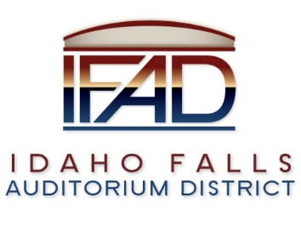

Mr. Swanson and herself to discuss the critical points of the contract. Mr. Swanson seconded the motion. Mr. Nitschke stated that having two people that already think the Centennial and Centennial alone can operate the Event Center are not the best to negotiate a contract protecting the interests of the board, community or the taxpayers. A vote was called. Motion passed. 3 - Yay, 1 – Nay and 1 – abstained.

- CSL Feasibility Study Contract Update – Legal Counsel stated the contract had been negotiated and signed by both parties and CSL was beginning performance.

- Event Center Design Requirements – Mr. Nitschke stated that a real determination of a successful design is whether it meets the customer requirements, not exceeds them or fails to meet them. Mr. Nitschke pointed out that the contract with CSRA required that the owners (the board) provide the requirements for the Project and have a written program which shall set forth the objectives, schedule, constraints and criteria….Also that it appears that the required document does not exist.". Mr. Nitschke suggested having an independent review of the design requirements. Mr. Nitschke believes there has been a kind of ‘group think’ on the design requirements of the Event Center without independent thought. Chair Gazdik reminded the Board that there were many years of work completed by past Boards to get to this point in the design process. Mr. DeKold reviewed design process. Mr. Nitschke replied he would like to see something other than meeting minutes to reference the history of the design process. Legal Counsel asked Mr. DeKold if there was anything that CRSA needed from the IFAD Board at this point in time. Mr. DeKold stated that there was nothing CRSA needed at this time from the Board. Mr. Swanson and Mr. LoBuono both agreed that they do not want to go back and review and question the design decisions made by previous Boards. Mr. Swanson asked Mr. Nitschke to identify who was questioning the Event Center design. Mr. Nitschke said it didn’t matter who they were, and assured the Board much of his concern stemmed from his own observations and his due diligence to this project. Legal Counsel reviewed with the Board his accounting of the process in which previous design decisions were made. Mr. Nitschke would like to know the criteria that justified the previous design decisions. Mr. LoBuono agreed with Chair Gazdik and Mr. Swanson he was not interested in going backwards and questioning the design decisions made by previous Boards. Mr. Nitschke stated he is interested in a review of the plans and felt this would be a prudent decision as the Board prepares to enter the fundraising phase of the project. He added that the correct plan is one that aligns with the requirements as set by the Board as owner representatives the Event Center building. Mr. Nitschke is interested in seeing the requirements, and would like to address any changes that may be suggested prior to the launch of the fundraising campaign. An independent review could be useful, he added. Mr. Nitschke is supportive of operation input, but leery of any design changes without an independent review. Chair Gazdik stated that the long term viability of the Event Center is based on maximizing profits to the operator in the long term. Mr. Clements commented that the programming guide helped define the building design. He suggested the Board may want to review the programming guide.
Mr. Nitschke expressed reservations about the board being good stewards of the public funds. Chair Gazdik stressed the importance of recognizing the
work completed by previous Board members. She is not willing to undo the
work that has been already been completed by previous IFAD Boards. Mr. Nitschke stressed it would be prudent for the Board to have an independent review of the design requirements. He is disturbed if the Board is unwilling to evaluate and review previous work. Mr. Nitschke’s stated reservations moving forward without a thorough review of the proposed contract with CM. Mr. Nitschke pointed out the Board’s need of a contrarian point of view in light of the public dollars being spent on the
project. Mr. DeKold suggested there be a review of the documents that led to the current design, which would then assist in the development of a requirements document. Mr. DeKold said there is much information up on their FTP, however, the site was recently down for maintenance and should be up and running soon.
Action: Executive Director Scott and Mr. DeKold will meet and put together a programming and requirements document for further review. Mr. Nitschke would like to know if the requirements were met. He believed it may be a timely place to have the review as the IFAD sets to launch the fundraising campaign in the near future.

- Reports and Updates
- Executive Director’s Report – Public Relations RFP update – Deadline extended to April 6, 2018. Four of the five firms approached are expected to submit responses. Credit Card Payments – Bank of Idaho had an excellent program available, charging a 3% fee to users of the credit card service. IFAD would not incur any cost, but it would provide an alternative option for payment. This could also be used for the fundraising efforts as well. Evolution Design, graphic designers, has been selected to work with IFAD and Pathway in developing the fundraising packet. Mr. LoBuono asked for clarification on the Project Management Plan. Mr. Nitschke asked for a hard copy of the Executive Director’s weekly report. Legal Counsel suggested sending emails with a read-receipt, helping the sender know if recipients have received emails and attachments.
- Legal Report – Legislature has not made any statutory changes that would affect IFAD since the last meeting. CSL contract reviewed, signed and submitted. Mr. Nitschke noted that a revised schedule needs to be discussed, if found to be necessary. Mr. Nitschke asked when the Optional Economic Impact Analysis would be discussed and suggested a deadline to identify if option is needed. Legal Counsel agreed and suggested consideration of the option four weeks into the CSL contract. Action: Executive Director Scott will communicate with CSL to identify last date available for the Board to require Optional Economic Impact Analysis.

- Calendar and Announcements
  - Upcoming IFAD Meeting/Events – Next Meeting on Wednesday, April 11, 2018
  - Announcements and Minor Questions – None.

- Adjournment – Meeting adjourned at 7: 57 a.m.

