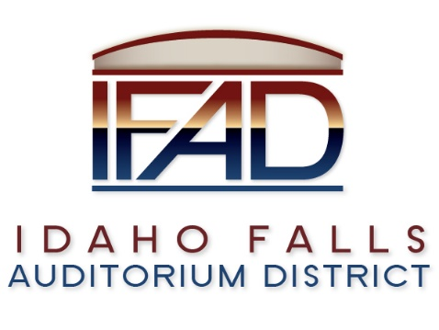
Board of Directors — Regular Business Meeting
425 N. Capital Ave., Idaho Falls, ID 83402
Tuesday, 27, March 2018, 7:00 a.m.

Location: The large conference room in Offices of Fuller & Beck
410 Memorial Drive
Suite 201, Idaho Falls, Idaho 83402

In Attendance: Board members Chair Terri Gazdik, Jill Kirkham, John LoBuono, Doug Swanson, Bob Nitschke, Legal Counsel Mark Fuller, Administrative Coordinator Brandace Novack, Blake Davis, James West Kassy Shepherd, Mike Clements, Kevin Greene, Kevin DeKold, Steve Vucovich and Kevin Bruder via conference.

- Call to Order – 7 a.m.

- Adoption of the Consent Agenda – Motion to accept the consent agenda. All in favor. Motion passes.
  - Meeting Minutes – 3/13/18 –
  - Approval of IFAD Payables -

- Public Comment – There is no public comment.
- Centennial Management Contract Discussion – Mr. Nitschke believes it is not timely to negotiate a contract with CM. Mr. LoBuono stated he felt it was premature as well to negotiate a contract with a single management team. However, he continued to state as did Mr. Swanson that it may be a good idea to work out the guidelines of the contract in advance. Chair Gazdik stated that IFAD would have a clearer vision moving forward. CM has a lot of resources that we could be utilizing at this point. Mr. Nitschke suggests working on the points in the contract proposal one at a time moving forward. Mr. LoBuono agrees with Mr. Swanson that we should be knowledgeable on the points of the contract. The Board does not have to sign the contract, however, it would be ready for discussion. Chair Gazdik would like the critical points of the discussion brought to light. Legal Counsel suggests a motion. Chair Gazdik motions to form a sub-committee to discuss the critical points of the contract. Mr. Swanson seconds the motion. Mr. Nitschke has reservations about the board being good stewards of the public funds. Chair Gazdik stresses the importance of recognizing the work of previous Board members. *** Mr. Nitschke’s has concerns about moving forward without a thorough review of the proposed contract with CM. A vote is called. Motion passes 3 in favor and 2 against.

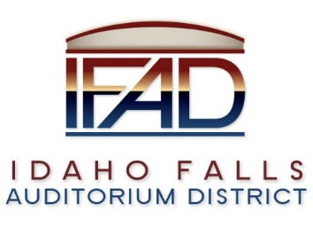

- CSL Feasibility Study Contract Update – Legal Counsel stated…

- Event Center Design Requirements – Mr. Nitschke stated that a real determination of a successful plan is whether requirements have exceeded expectations or have not met with expected requirements. Mr. Nitschke suggests having an independent review of the design requirements. Mr. Nitschke believes there has been a ‘group think’ on the design of the Event Center. Chair Gazdik reminded the Board that there were many years of work completed by past Boards to get to this point. Mr. DeKold comments. Mr. Nitschke replies. (19 Minutes). Legal Counsel asks Mr. DeKold if there was anything that CRSA needs from the IFAD Board at this point in time. Mr. DeKold stated that there was nothing CRSA needed at this time from the Board. Mr. Swanson and Mr. LoBuono are both in agreement that they do not want to go back and review and question the design decisions made by previous Board’s. Mr. Clements commented that the programming guide helped define the building design. He suggested the Board may want to review the programming guide. Mr. DeKold made a suggestion that there be a review of the documents that led to the current design, which would then assist in the development of a requirements document. FTP. Action: ED Scott, Architect DeKold and Mr. Nitschke will meet and discuss putting together a requirements document.

- Reports and Updates
- Executive Director’s Report - PR RFP update-deadline extended to April 6, 2018. Four of the five firms approached are expected to submit RFPs. Credit Card Payments – Bank of Idaho had an excellent program available, charging a 3% fee to users of the credit card service. Evolution Design, graphic designers, has been selected to work with Pathway in developing the fundraising packet. Mr. LoBuono asked for clarification on the Project Management Plan.
- Legal – CSL contract reviewed, signed and submitted.
- Calendar and Announcements
  - Upcoming IFAD Meeting/Events – Next Meeting on Wednesday, April 11, 2018
  - Announcements and Minor Questions

- Adjournment – Meeting adjourned at 7: 57 a.m.

