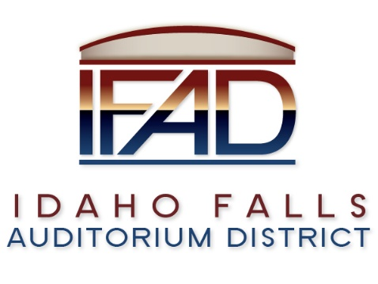
Board of Directors — Regular Business Meeting
425 N. Capital Ave., Idaho Falls, ID 83402
Tuesday, 27, March 2018, 7:00 a.m.

Location: The large conference room in Offices of Fuller & Beck
410 Memorial Drive
Suite 201, Idaho Falls, Idaho 83402

Agenda

- Call to Order

- Adoption of the Consent Agenda
  - Meeting Minutes – 3/13/18
  - Approval of IFAD Payables

- Public Comment – anyone wishing to provide public comment will be given 3 minutes
- Centennial Management Contract Discussion

- CSL Feasibility Study Contract Update

- Event Center Design Requirements

- Report and Updates
- Executive Director’s Report - PR RFP update, Credit Card Payments
- Legal
- Calendar and Announcements
  - Upcoming IFAD Meeting/Events – Next Meeting on April 11, 2018
  - Announcements and Minor Questions

- Adjournment

Posted on or before 7:00 a.m. on March 23, 2018

