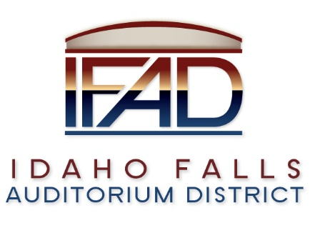
Board of Directors — Special Business Meeting
425 N Capital Ave., Idaho Falls, ID 83402
Tuesday, 6 February 2018, 7:00-8:30 a.m.

Meeting Location: Large conference room in the Offices of Fuller & Beck located at 410 Memorial Drive, Suite 201, Idaho Falls, Idaho 83402.

In attendance: Board Members: Chair Terri Gazdik, John LoBuono, Bob Nitschke, Jill Kirkham via conference call, Doug Swanson, Legal Counsel Dan Beck, Administrative Coordinator Brandace Novack, Executive Director Brian “Chip” Scott, Kevin Greene, Jeff Sayer via conference call, James West, Blake Davis, Mike Clements, Kassy Shepherd, Isabella Alves and Mayor Rebecca Casper.

Agenda

I. Call to Order – Chair Gazdik calls meeting to order at 7 a.m.

II. Adoption of the Consent Agenda – Motion to change the agenda and date of next meeting set for February 27, 2018. Motion is seconded and passes.
A. Meeting Minutes – Mr. Nitschke suggests a few changes on the January 23, 2018 minutes before approval. Action: Minutes’ revision. Scheduled for approval at the next meeting.
B. Payables – Motion to approve the payables. Motion is seconded and passes. Business cards and Adobe editing tool.
C. Financial Statements – None.

III. Public Comment – None.

IV. TEG Global – Darwin Mecham – not present. Mr. Mecham sent a message via the Chair thanking IFAD for selecting TEG to search for the new Executive Director, and inviting them to be part of the process.

V. Executive Director Welcome – Mr. Scott addressed the meeting. His family relocation went without incident and the movers show up today.

VI. Discuss orientation for Executive Director – Chair Gazdik requested that each Board member meet with Mr. Scott, one-on-one, within the next two weeks.

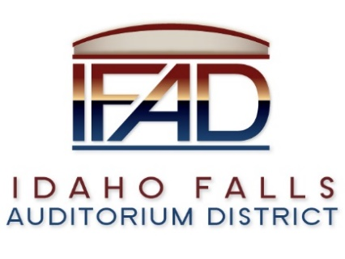
VII. Report from Chair – A venture capital group contacted the Chair regarding an East Coast Hockey (ECH) team. According to the Venture Capital Group, the importance of a junior team is stressed because the public tends to grow attachments to the junior players as their careers progress. Junior players play in hopes for a college scholarship. Mr. Greene believes IFAD would see two thousand attendees per game for junior hockey, however, he does not believe the community could support two hockey teams at this time with the current size of the population and it may be 10 to 15 years before there would be such support.

VIII. Discuss Road and Bridge development – There is a question for Ball Ventures. Mr. Nitschke asked about incorporating a bike path/bridge into the plan. The city plans on incorporating the bike path and pedestrian bridge into the plan as pedestrian traffic is considered.

IX. Update from Pathways on fundraising readiness project – Mr. DeKold agrees that it is okay to show the schematic design as is, however, a professional rendering would be more realistic. Pathways’ report update. Mr. Swanson suggests adjusting timeline of Pathways report in accordance with the actual hiring date of the ED. Request to adjust will be considered if requested.

X. Update on status of Feasibility Study, discuss review process, criteria and
timing – Mr. Nitschke suggests adding the consideration of a minor league hockey team to the Feasibility Study. Proposals are due today. Mr. Nitschke offers to take the lead on the review process, compile information and present findings to the board. After board consideration, the next step would be to send selected recommendation to Legal Counsel to enter into a contract for hire. Award date to be determined. Final proposal expected to arrive today, which is the deadline to receive proposals. Mr. Nitschke would like to establish and define terms of evaluation for the proposals. A work session is scheduled for 3 PM on February 16th, 2018 to discuss the RFP’s that have been submitted. Action: Submit questions for consideration to Mr. Nitschke by the 14th of February, 2018.

XI. Public Relations – No comment at this time.
A. Update from committee – Mr. Schwarze not present.
B. Status of PR RFP – Mr. LoBuono explained status of the outline. Appendix I of the Feasibility Study RFP was incorporated into the PR RFP. A short list of PR firms were selected to receive a request for proposal. Fee structures

were discussed – retainer or hourly rate? Mr. Nitschke would like to see the proposal be more defined. In order to develop a communication plan, for example, Mr. Nitschke would define this task in more detail, requesting the firms give a more detailed scope of work. Mr. LoBuono clarified that PR work
is a fluid discipline, and first stage proposals are typically more open ended. Pathways has indicated that a PR firm is an integral part of its fundraising plan, and is required to further the progress of the Events Center. Chair Gazdik would like to see a more proactive approach to public relations. She believes that a PR firm is essential for the future success of the project. Mr. DeKold made a few suggestions, specifically suggesting that the language be removed stating there could be a second round of requests for proposals. This could discourage complete first round submissions. Mr. Swanson gave a specific example of how a PR firm could have served the project well more recently, and referenced the media coverage of the termination of the previous ED’s contract. Mr. Nitschke does not like the way the RFP is currently written, and advises a revision. Action: ED Scott and Mr. LoBuono will work on the RFP together, refine key points, and take into consideration the concerns addressed by the Board and partners.

XII. Report and Updates
- Administrative – Action: Update: Revised meeting calendar – There is a motion to cancel the meeting on Dec. 26, 2018. All in favor. Motion passes.
Proposal on letter board – Action: ED Scott will review options for notice/agenda board.
Other – Action: Work order submitted to IdeaCom to install an intranet connection in the large conference room for the meeting/conference phone.
B. Legal
i. Legislative update – Legal Counsel Mr. Beck. At this point in the Legislative session, they have managed to discourage any legislation that would revise, amend or change the Auditorium District statutes. Future legislation could impact ADs if urban renewal revenues are used. It is important to keep an eye on any legislative developments moving forward.
ii. Other – none.

XIII. Calendar and Announcements - Upcoming IFAD Meeting/Events
A. Next Board Meeting on Friday, 16 February at 3 p.m. for a work session, followed by a regular business meeting on 27 February 2018 at 7 a.m. (Tuesday)
B. Announcements and Minor Questions – None.

XIV. Adjournment 8:24 a.m. (approximate time)

