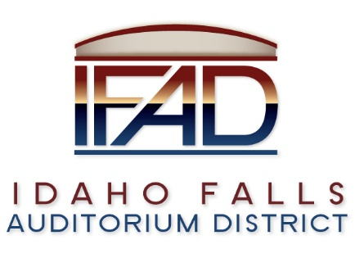
Board of Directors — Special Business Meeting
425 N Capital Ave., Idaho Falls, ID 83402
Monday, 15 January 2018, 6:00-9:00 p.m.

Meeting Location: Large conference room in the Offices of Fuller & Beck located at 410 Memorial Drive, Suite 201, Idaho Falls, Idaho 83402.

In attendance: Board Members: Chair Terri Gazdik, John LoBuono, Bob Nitschke, Jill Kirkham, Doug Swanson via zoom, Legal Counsel Mark Fuller, Administrative Coordinator Brandace Novack, Brian “Chip” Scott, Paul Harker, Darwin Mecham, Tyson Bolkcom and Kevin Greene.

Agenda

- Call to Order – Chair Gazdik calls meeting to order at 6 p.m.

- Motion to approve consent agenda – All in favor. Motion passes.

- Darwin Mecham – TEG Global – Update on recruiting process and instructions on interview process. Mr. Mecham reviews criteria for the hiring process. There were initially ten applicants, two of which were selected to present to the full board. Background checks are run through a company called Precise Hire. TEG Global helped to develop questions for the Board to interview the candidates. The Board reviews Q & A process.

- Presentation from Executive Director candidates
First candidate 6:15 – 6:45 – Chip Scott
Q & A 6:45 p.m. – 7:00 p.m.
Second candidate 7:15 – 7:45 - Paul Harker
Q & A 7:45 p.m. – 8:00 p.m.

- Executive Session: § 74-206(1)(a) To consider hiring a public officer,
employee, staff member or individual agent, wherein the respective
qualities of individuals are to be evaluated to fill a particular vacancy or need. Executive Session extended from 8:21 p.m. to 9:02 p.m.

VI. Public session - Executive Director – discussion and vote on filling the position. Chair Gazdik invites a motion to extend an employment offer to Chip Scott. Motion is made and seconded. Motion passes.

A. Request board approval to enter into contract negotiations with
Chosen candidate for Executive Director position. Mr. Nitschke was assured by hiring committee that all candidates were thoroughly evaluated.

B. Media announcement – Press Release – There will be no press release at this time. Employment contract negotiations will be conducted by Legal Counsel and Board Chair.

VII. Operational feasibility study – discuss and approve RFP, companies to whom the RFP will be submitted.
Mr. Nitschke reviews process of developing the “Request for Proposal”. Motion is made to approve RFP. Motion seconded. All in favor. Motion passes.

VIII. Adjournment 9:18 p.m. (approximate time)

