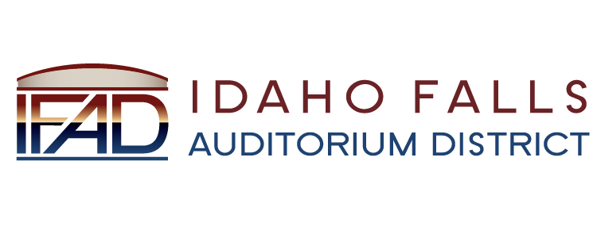
NOTICE POSTED PURSUANT TO IDAHO OPEN MEETING LAW CODE 67-2343

Idaho Falls Auditorium District

A Business Meeting of the Board of Directors
will be held at the following location:

The Offices of Fuller & Beck
Large Conference Room
420 Memorial Drive
Suite 201
Idaho Falls, ID 83402

Tuesday, 23 January 2018

7 AM

Notice posted on or before 18 January 2018
Date and time subject to change

