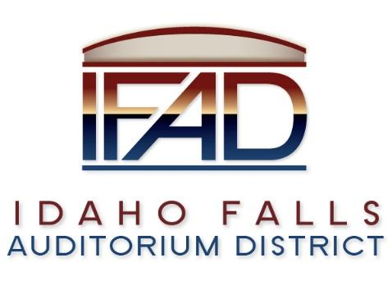
Board of Directors — Regular Business Meeting
425 N. Capital Ave., Idaho Falls, ID 83402
Tuesday, May 8 2018, 7:00 a.m.
Location: The large conference room in Offices of Fuller & Beck
410 Memorial Drive
Suite 201, Idaho Falls, Idaho 83402

Agenda

- Call to Order

- Adoption of the Consent Agenda
  - Meeting Minutes – 3/27/18 & 4/24/18
  - Approval of IFAD Payables
  - Financials

- Public Comment – anyone wishing to provide public comment will be given 3 minutes

- I.E. Productions Public Relations RFP Presentation – Chad Hammond

- PR RFP Selection Discussion and Vote – John Lobuono

- CSL Report via Conference Call – Bill Krueger

- Executive Director Priorities – Bob Nitschke

- Event Center Design Requirements and Public Meeting

- Report and Updates
- Executive Director’s Report – Business Plan/Project Management, Admin Staff
- Legal – Update on Agenda Protocols Review

- Calendar and Announcements
  - Upcoming IFAD Meeting/Events – Next Meeting on May 22, 2018
  - Announcements and Minor Questions
  - Board & Public Input for May 22 Agenda

- Adjournment

Posted on or before 7:00 a.m. on May 6, 2018

